Micah Ecumenical Ministries

September 2011

Micah Ecumenical Ministries
P.O. Box 3277
Fredericksburg, VA 22402
1013 Princess Anne St.
Fredericksburg, VA 22401
(540) 479-4116
FAX (540) 479-4121
Executive Director, Meghann Cotter

Micah Ecumenical Ministries, 2011 Strategic Plan Summary

Micah has developed a set of strategic goals that will guide its work for the five years. The following is a summary of those plans.

Staff Objectives
- Making Services More Hospitable
  - To perfect service provision among all programs, so that the Micah experience is as close to home as possible for those without.
- Reassessing Staff Needs and Organizational Responsibilities
  - To further expand the community of partners, both paid and volunteer, who are working on the Micah cause.
  - To form a more consistent and equipped team of staff and volunteers
  - To better define the different responsibilities of the Clergy, Board and the Executive Servant-Leader.
- Offering Coordination to Community Meals
  - To improve accessibility, communication and consistency among community meal sites
- Keeping Tabs on Advocacy Areas
  - Police, hospital, jail, downtown businesses, local governments, politicians, general community education, fostering relationships with guests, guest perception of the community and sharing our model with other communities.

Board Objectives
- Develop Next Major Program Areas
  - Housing and Support Services
    - To develop a multi-pronged effort that houses and supports the primary street population.
    - Micah’s role in sheltering the homeless is strictly emergency. Beyond providing relief from the cold, our long-term plan is to direct remaining resources toward permanent housing.
    - While Micah does not see itself as a community-wide financial assistance provider, it does plan to participate in the larger issue as a catalyst for community dialogue.
  - Employment
    - To improve the application, resume and job search assistance provided by volunteers, staff, and community resources who come to Micah.
    - To develop Micah’s giving back program as a multi-tiered employment project that both meets productive volunteerism needs and serves as a stepping stone for those needing to work through a program, learn skills, grow personally and transition back into the mainstream workforce.
- Improve Marketing and Community Perception
  - To grow community understanding of those who live on the street and the community’s role in addressing the issue.
  - To find more ways to bring Micah into the churches; and get the churches and clergy to interact more with Micah and its population.
- Developing a Fundraising Strategy
  - To establish clear deadlines and strategies for obtaining and maintaining a donor base.
  - To present opportunities for existing supporters of Micah to give in different ways and introduce new donors to the work Micah is doing.
  - To diversify grant opportunities for specific and general programming
  - To develop financial partnerships with individuals and organizations whose investment would assist their specific needs, while growing Micah programming.
1. Micah Ministries

1.1 Executive Summary

Micah Ecumenical Ministries (Micah) is a tax-exempt, non-profit service provider focused on providing services to the homeless in Planning District 16, which includes the city of Fredericksburg and the counties of Stafford, Spotsylvania, King George and Caroline. Our mission, to serve the community’s neighbors in need is driven by the biblical call of Micah 6:8, “He has showed you, O man what is good. And what does the Lord require of you? To do justice and to love kindness and to walk humbly with your God.” We envision a community where everyone works together to ensure housing, work, health care, education and a support network for all. Currently, we offer a holistic approach to aiding the homeless. Efforts includes a daytime hospitality center, a cold weather shelter, and a Residential Recovery Program—a state-licensed group home for homeless who are leaving the hospital in need of temporary or terminal care. Although driven by a Christian mission, our services are available to those in need of all faiths.

1.2 Mission Statement

Micah, a Christ-inspired community, is helping homeless people reach their greatest potential.

1.3 Vision Statement

Micah, a Christ-centered ministry: bringing the community together so that no neighbor goes in need.

1.4 Core Values
Responding to the biblical call of Micah 6:8, we strive to...
Do Justice by:
• Being a community conscience
• Responding to unmet needs
• Offering hope
Love Kindness by:
• Fostering relationships of trust, respect and mutual support
• Acknowledging every person’s dignity
• Providing holistic care that empowers those in need to accept ownership and responsibility
Walk humbly with God by:
• Continuing the work of Christ
• Practicing servant-leadership
• Educating and mentoring the community to care for “the least of these”

1.5 Organization History and Summary

Downtown Fredericksburg congregations have been involved with our community’s homeless population since the late 1980s, when they opened their church buildings as shelter space and provided meals to those in need. However, as the area’s original shelter program, now the Thurman Brisben Center, grew and redeveloped its programs, many people who lived chronically on the street found themselves ineligible for those services due to unmedicated mental illnesses, disabilities, criminal backgrounds and other barriers. After the Thurman Brisben facility relocated to a new building in an industrial park in 2005, a number of downtown churches came together to organize ways of assisting those whose needs were not being met by existing service providers.

Member Churches
The original seven churches included Fredericksburg Baptist Church, The Presbyterian Church of Fredericksburg, Fredericksburg United Methodist Church, Shiloh (Old Site) Baptist Church, St. George’s Episcopal Church, Tower of Deliverance Church, and Trinity Episcopal Church. St. Mary of the Immaculate Conception Roman Catholic Church and Christ Lutheran Church were added in 2008 and Shiloh (New Site) Baptist Church was added in 2009. In 2010, Micah’s governing board adopted provisions that allowed for the participation of partnering churches—congregations that were not located in the downtown Fredericksburg area, but had a qualifying interest and investment in Micah’s work. Ebenezer United Methodist Church and Mt. Ararat Baptist Church in Stafford and Tabernacle United Methodist Church in Spotsylvania have thus far come on board as partnering churches.

Governance
In response to God’s call to do justice, and to love kindness, and to walk humbly with your God (Micah 6:8), Micah Ecumenical Ministries was incorporated on January 14, 2005. The organization was initially governed by a Clergy Caucus, which included the head pastors of each founding church. The Clergy Caucus later delegated governance responsibilities to a Board of Directors, comprised of appointed representatives from each of the their churches. These representatives and three clergy, elected annually by the caucus, make up a 13-member Board. Current board members include:

Chair: Robert Bos, Fredericksburg United Methodist Church
Treasurer: Richard Caporalli, St. Mary of the Immaculate Conception Roman Catholic Church
Secretary: Keziah Walker, Shiloh Old Site Baptist Church
Clergy Convener: Rev. Larry Haun, Fredericksburg Baptist Church
Clergy: Rev. Jim Dannals, St. George’s Episcopal Church
Clergy: Rev. Richard Carbaugh, Christ Evangelical Lutheran Church
Steve Scheibe, Christ Evangelical Lutheran
Mary Woolls, St. George’s Episcopal Church
Joanne Beck, Trinity Episcopal Church
Fred Rankin, Fredericksburg Baptist Church
Doug Richardson, Shiloh New site Baptist Church
Jeff Kunkler, Presbyterian Church of Fredericksburg

The Clergy Caucus remains involved as the organization’s theological compass. Both the Board and the Clergy meet monthly.

Staffing
Micah is staffed by 6 full-time salaried employees:
Executive Servant-Leader
Servant-Leader of Volunteers
Community Care Liaison
S.O.A.R. (SSI/SSDI, Outreach, Access and Recovery) Coordinator
P.A.T.H. (Partners Assisting in Transitions from Homelessness) Outreach Worker
Health Care Navigator

5 hourly employees:
Bookkeeper
4 residential aides in the Residential Recovery Program

And 4 seasonal employees
Cold weather shelter facilitator
3 Cold weather shelter overnight monitors

Hospitality Center
The Board initially appointed a steering committee to oversee the operation of Micah’s first official program, the Hospitality Center—which opened on April 14, 2005. The steering committee hired the agency’s first employees, who managed the center for two and half years from the basement of Trinity Episcopal Church. The center relocated in September 2007, after Fredericksburg Baptist Church purchased the current storefront location at 1013 Princess Anne St. The steering committee was dissolved upon the hiring of an Executive Director in July 2007.

Cold Weather Shelter
The Salvation Army opened the first cold weather shelter in Fredericksburg in 1995, after the city officials responded to neighbor complaints by handing down tighter restrictions on Thurman Brisben Shelter. The new rules—which restricted beds, required self-help programs, and capped the number of days residents could stay—excluded many chronic homeless from the program. In 2002, the program moved to Bragg Hill Family Life Center, under the guidance and support of a loosely organized group of churches and volunteers. The shelter was adopted under Micah’s umbrella in 2005. It operated from Bragg Hill Family Life Center until the winter of 2009-2010, when Micah renovated and opened a permanent space at 750 Kings Highway—an old school building owned by the Rappahannock Area Community Services Board. Initially, the shelter was funded solely by the city of Fredericksburg and opened only when the temperature dropped below 25 degrees. In winter 2007, the temperature at which the shelter opened was raised upon receipt of support from Stafford, Spotsylvania, Caroline and King George Counties. Currently, the shelter is consistently supported by Fredericksburg, Spotsylvania and Stafford.

Residential Recovery Program
Micah’s vision for respite care was born in 2004, after the Fredericksburg Baptist Church rented a temporary apartment for a dying homeless man. The desire to offer dignity to that man in his final days led Micah leaders to partner with the Mary Washington Hospital Foundation in April 2008. Micah rented two apartments at 1118 Caroline Street as shelter for the recovering and terminally ill who are discharged from hospital care with no place to go. After two years, agency leaders identified the need for an expanded program, with increased supervision and case management. A substantial grant from the Mary Washington Foundation enabled Micah to open a 24-7, supervised facility, which is licensed as a group home by the Virginia Department of Behavioral Health and Developmental Services. The program opened with four beds on May 6, 2010 and was full with a waiting list by the following week. It expanded to eight beds in September 2010.

Micah Ministries aspires to continue developing programming that eliminates the need for any vulnerable person to go without work, housing, health care, or education.

1.6 Legal Entity
Micah Ecumenical Ministries is a 501(c)3 nonprofit organization

2. The Problem of Homeless in the United States and in Planning District 16
Homeless is increasing throughout our region both as a result of an increase of the population and as a result of the recent economic downturn.

2.1 National, State, and Local Statistics on Homelessness
At the national level:
According to National Point in Time statistics from The National Alliance to End Homelessness:
There are 671,859 people experiencing homelessness on any given night in the United States. That means 22 of every 10,000 people are homeless. Of that number
• 37 percent are families (an estimated 85,000 per night)
• 63 percent are individuals
• 18 percent are considered chronic (an estimated 124,000 per night)
• 20 percent are veterans (an estimated 131,000 per night)
The current recession is expected to force another 1.5 million Americans into homelessness over the next two years, according to the National Alliance to End Homelessness.

Additional studies demonstrate that the costs of managing homelessness are far higher
than working to end it.

• According to a report in the New England Journal of Medicine, homeless people spent an average of four days longer per hospital visit than comparable non-homeless people. This extra cost, approximately $2,414 per hospitalization is attributable to homelessness

• A study of hospital admissions of homeless people in Hawaii revealed that 1751 adults were responsible for 564 hospitalizations and $4 million in admission costs. Their rate of psychiatric hospitalization was over 100 times higher than their non-homeless cohort. The researchers conducting the study estimate that the excess cost for treating these homeless individuals was $3.5 million or about $2,000 per person.

• According to a University of Texas two-year survey of homeless individuals, each person cost the taxpayers $14,480 per year, primarily for overnight jail.

• A typical cost of a prison bed in a state or federal prison is $20,000 per year.

• A study conducted by HUD found that the cost of an emergency shelter bed is approximately $8,067 more than the average cost of a federal housing subsidy.

At the state level:
The rate of unemployment has been increasing dramatically since it last bottomed out in April of 2007. According to the U.S. Bureau of Labor Statistics:
• 2.7 percent of Virginians were unemployed in April 2007
• By April 2008, unemployment had increased to 3.1 percent
• By April 2009, the rate had more than doubled to 6.3 percent
• It peaked at 7.8 percent in February 2010, setting the last highest rate of 7.1 percent set in January 1992

According to the Virginia Employment Commission:
• The City of Fredericksburg has recently experienced a higher unemployment rate than the rest of the state, with a rate as high as 9 percent.
• The counties of Spotsylvania and Stafford have recently experienced lower unemployment rates than the rest of the state, hovering between 5 and 6 percent.

Foreclosure levels in Virginia have remained nearly half the U.S. rate, but the numbers have risen rapidly. According to the Mortgage Banker’s Association and RealtyTrac.com
• The Fredericksburg, Stafford and Spotsylvania area had a 2 percent foreclosure rate as of March 2008.
• Spotsylvania, however, topped the state’s foreclosure rates in February 2009, with 1 in 199 housing units receiving a default notice. Stafford not far behind as the state’s fourth highest, with 1 in 221 housing units receiving a foreclosure filing. The City of Fredericksburg was in the top 20 in the state.
• In June 2010, 1 in every 587 households received a foreclosure filing in Fredericksburg; 1 in 264 received notice in Spotsylvania; and 1 in 259 received notice in Stafford.

At the local level:
The 2010 Point in Time Count, conducted annually by the Continuum of Care revealed that on any given night 288 individuals were considered homeless by HUD’s definition. HUD considers someone homeless if he/she is staying in shelters, transitional housing, or sleeping in places not meant for human habitation (parks, alleys, all night establishments such as restaurants, hospitals, Laundromats, in vehicles, etc…).
- 184 of those individuals were adults
- 104 were children
- 83 of the adults were considered chronically homeless
- Another 376 children identified during the Point in Time count as homeless under the Department of Education’s definition, which includes children living with friends or family or in motels.

Compared to the 2009 Point in Time count, the homeless population increased by 10 percent in a year’s time. 603 people were counted as homeless that year.
• 145 adults were considered HUD homeless
• 57 children were considered HUD homeless
• 401 were considered homeless under the Department of Education’s definition

Compared to the 2008 Point in Time count, the homeless population increased by 16 percent in two year’s time. 570 people were counted as homeless that year:
•144 adults were considered HUD homeless
• 50 children were considered HUD homeless
• 376 children were considered homeless under the Department of Education definition
** There is some uncertainty in the 2008 numbers, as counters believe that some children may have been counted twice, once under HUD homeless and once by the Department of Education.

2.2 The Causes of Homelessness
Homeless people typically stumble into their circumstances for three reasons: disabilities, barriers, and substance abuse. Challenges of the disabled homeless range from mental health and intellectual disabilities to mobility issues and chronic medical concerns. A report from the Substance Abuse and Mental Health Services Administration (SAMHSA) says that 39% of homeless report some form of mental health problems, with 20-25% meeting the criteria for serious mental illness. It further indicates that 3% report having HIV/AIDS; 26% report acute health problems other than HIV/AIDS such as tuberculosis, pneumonia, or sexually transmitted diseases; and 46% report chronic health conditions such as high blood pressure, diabetes, or cancer.

The barrier homeless experience setbacks due to low wages, divorce, domestic violence, single parent households, criminal histories, previous evictions, poor credit, and spotty work histories. As part of the two-thirds of America (Source: American Payroll Association) living paycheck to paycheck, they often fall short of what they need to get by. The Point in Time count identified that 66% of the homeless in Planning District 16 as unemployed. The Encyclopedia of Homelessness states that one-third of homeless have serious criminal histories.

Substance abuse among the homeless is also a significant problem. According to SAMHSA, 38% of homeless report alcohol problems and 26% report other drug use problems.

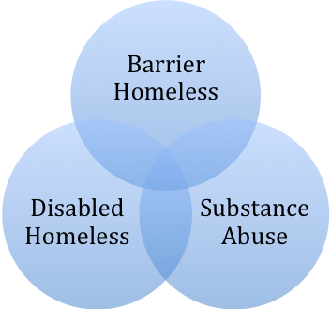

While many homeless fall into just one category, most are impacted by two or more of these dynamics. In particular, there is great overlap in the homeless experiencing serious mental illness, substance abuse, and having a criminal history. SAMHSA indicates that half of all mentally ill homeless are also self-medicating with drugs or alcohol. They are also twice as likely to be arrested. Often, someone starts out as just a disabled homeless person, but acts out on his/her mental illness and ends up with a barrier after landing in jail. Or, someone living with marginal income begins using and dealing drugs as an alternative survival tactic. Still others become disabled due to domestic violence and begin to drink as a result of physical and mental victimization.

The more that these categories overlap, the more likely a person is to be chronically homeless--living in shelters or places not meant for human habitation for longer periods of time or in frequent episodes. They are the most limited in their access to housing, health care, employment and educational resources. And they are considered the most at great risk. According to the National Health Care for the Homeless Council, people who experience long stints of homelessness are three times more likely to die than the general population. The average age of death of a homeless person is about 50, the life expectancy of someone living in 1900. Non-homeless Americans can expect to live to age 78.

Micah serves all who stumble into homelessness, but this group, considered the most vulnerable, is our target. With so many circumstances working against them, it is this group that turns up at Micah absent of hope, harboring great cynicism, and having burned bridges with other community services. It is through a relationship-based approach that Micah begins to chip away at these issues and set these individuals back on track.

2.3 Profile of Micah’s Guests

Micah guests are most often our neighbors--people who have grown up or become homeless in the Fredericksburg, Stafford, Spotsylvania, Caroline and King George area. Fredericksburg’s location, centered off of I-95 and situated mid-way between Washington and Richmond, makes it a destination for those passing through or getting stranded in the community with no place to stay. Micah, however, is committed to assisting those who have social supports in other communities with the means to return. The following pie chart illustrates the last permanent residence of those identified as homeless in the 2010 Point in Time count, a one day census of those living in places not meant for human habitation, shelters, motels, or doubled up.

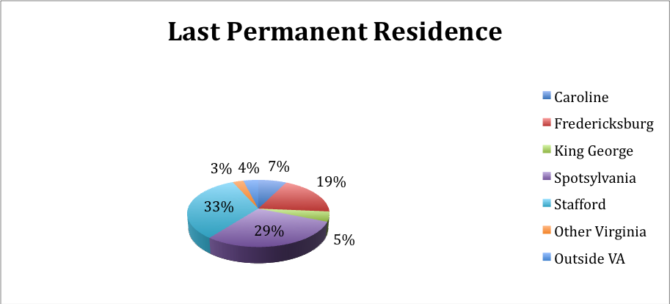

While the clientele is generally an older population, averaging around 41, there is a growing contingent of younger homeless. Many single newly homeless are coming into their circumstances as they age out of foster care or are excused from their parent’s homes at the age of 18. Ten percent of those surveyed in the Point in Time count left foster care for reunification or adoption.

For the most part, the population has completed either high school (33%) or a GED (13%), with a few (15%) attending some college and 7% completing a Bachelor’s Degree. Many (29%) have less than a high school education and 18 % were in special classes in school for some kind of developmental disability.

The 2010 Point in Time counted 41% females and 59% males, with the following racial breakdown:
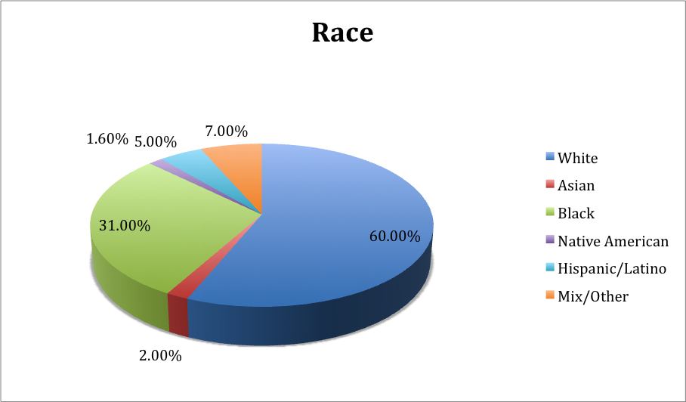

The count also concluded that more people (71% of those surveyed reported being homeless just once in the last 3 years, up from 8% in 2009) are currently becoming homeless for the first time and staying homeless longer (26% reported being homeless for 1-2 years, up from 18% in 2009). This fact, alongside the rising rate of foreclosures and unemployment in this area, has been pointed to as an indicator of the weak economy and its impact on the homeless population.

Most homeless do point to unemployment or eviction as reasons for their homelessness, but the numbers are shadowed by evidence of disabilities, mental health issues, substance abuse, credit concerns and criminal backgrounds.

3. Micah’s Approach to Ending Homelessness

3.1 Micah’s Philosophy

While many social and economic complexities cause homelessness, Micah’s experience has shown that those who find themselves homeless share similar deficiencies. They lack a family or support system to help them climb out of their circumstances. Sometimes their supporters have burned out on their care; other times, the individual is burned out on his/her family; and many times, the person has lost his/her family through death or a break in communication. Micah believes that when a person’s lacks such supports, the church and the community have to fill the gap.

For that reason, Micah maintains a service-method that goes beyond the traditional client-caseworker relationship. We openly embrace those we serve as members of our Micah family, supporting them during challenges on the street and continuing once they move indoors and work toward stability. The heart of our strategy stems from the teachings of Jesus Christ. We believe that exemplifying His unconditional love for the world, particularly for the poor and vulnerable, in our every day work will generate a healing power for the most difficult cases. The following are examples of how we have imbedded this philosophy in our work and some of the strategies that help us administer a unique service system:
• Using service-centered terminology. The word servant-leader is used for employees who work in director roles, indicating the importance of those who lead being servants first. The word guest is used in talking about our clients, indicating that our relationship with them extends beyond a business contract.
• Minimizing paid staff and maximizing volunteer service. Micah volunteers are empowered to take on tasks that are often reserved for paid staff in other organizations. Volunteers manage our kitchen, complete intake forms and assist with case management tasks.
• Constructing program rules so that they do not limit accessibility and continued services to the most vulnerable. Micah maintains a policy of not banning anyone from service, and offering a way for those who must be restricted from service to work their way back in. We also make every effort to minimize the paperwork and ease access to all services.
• Emphasizing unconditional love in service practice. Guests are frequently extended new chances to prove themselves and additional options, regardless of how they disappoint us or stray from their plan of care. We use this method to counter our guest’s assumption that our relationship with them will dissolve, like those of others in their lives, if they are not successful.

3.2 Micah’s Continuum of Care

Micah’s short and long-term vision includes a comprehensive menu of services, which are extended to clients at the rate and level that their individual journeys require. For some, that means simply supporting them in taking a daily shower or sitting in a room of people long enough to get breakfast. Others are capable of working on a more aggressive success plan that includes a series of steps aimed at improving their circumstances. Regardless of a client’s readiness for assistance, both approaches achieve Micah’s goal of holistic access to housing, health care, employment, and education. While the person who only works to meet his/her basic needs may benefit from a stay at the cold weather shelter (housing), assistance registering for the Moss Clinic (health), and participating in the Giving Back program (employment), a more self-sufficient client may obtain permanent housing, get a job, earn his/her GED and be successful in addressing his/her medical needs. This effort to merge education, employment, housing, and health services under one umbrella, creates a one-stop agency where related parties, with shared resources, are implementing a unified plan.

Most guests initially experience Micah through the Hospitality Center, where basic needs and case management serve as marketing for the agency’s broader system of service. Rather than expecting a largely mentally ill, disabled, and distressed population to navigate the employment agency for job help, the housing authority for housing, the free clinic for medical care, and the school system for their child’s educational needs, Micah merges program components that first shepherd a person off the street. At the hospitality center, staff and volunteers build relationships with guests and offer varying levels of support. If Micah does not provide the necessary service, we assist the guest in pursuing the community resource that meets his/her need. We take them to appointments, making phone calls with them and advocating on their behalf, much like a family member might do for a loved one. Micah teaches staff and volunteers to accompany these neighbors in need on their journey.

Micah expects that its ability to offer holistic care will grow over time, as it develops housing opportunities, maximizes partnerships that bring job opportunities, expands internal health resources, and fosters educational opportunities that reduce the chance that homeless children will follow in their parent’s footsteps.

3.3 Micah Ministries as a Service Provider

Micah clientele primarily sleep in places not meant for human habitation or in shelters. Although the definition of homeless from the federal Housing and Urban Development Authority excludes those living in motels or doubling up with friends or family, Micah accepts anyone who can legitimately demonstrate their risk of ending up homeless on any given night.

In calendar year 2009, Micah provided services to 957 people in Planning District 16. Those services included 2,331 nights of shelter for 131 individuals who would have otherwise slept outside at risk of freezing to death. We provided 1,460 bed nights to 30 different people who left the hospital in need of a place to stay while they were recovering or dying. The needs of 945 people were addressed with 18,876 visits to the hospitality center for breakfasts, showers, bag lunches, and clothing.

3.4 Micah’s Programs

1. Hospitality Center – The hub of all Micah programs, the hospitality center is a day-time basic needs and case management program. Breakfast, showers, bag lunches, clothing assistance, mail service, telephone access, and other basic needs entice guests to enter Micah’s doors. While there, they are approached by a full-time Mental Health Case Manager, who is employed by the Rappahannock Area Community Services Board. They have access to a full-time SOAR (SSI/SSDI, Outreach, Access and Recovery) Coordinator, who assists individuals needing to apply for Social Security benefits.

Intake staff flag clients with special needs. Clients only need to register once for a Micah program and update their information yearly. This enables a guest who arrives at the Micah Center to complete all the necessary paperwork and sign up for another Micah program the same day.

Because not everyone comes to Micah with the tools to aggressively pursue housing, the center equips those living outdoors with items that help them live as safely as possible. We provide tents, sleeping bags, blankets, and when possible, stoves and propane tanks during the winter. We supply bug repellant, sunscreen, and raingear in the summer

2. The Journey Program – Guests with needs beyond basic survival can meet with an array of trained volunteers who can help them troubleshoot the complexities of various community services. Whether the service is offered internally or by another community agency, Micah staff maintains a culture of not just referring clients to appropriate services, they work with the clients to facilitate their access to those services. All clients have equal access to case management services.

In 2010, Micah received funds for the Journey Program from the federal Department of Housing and Urban Development office to develop a service to assist chronically homeless clients who have income, typically from social security, with rental subsidies. Those participating in the program will be required to participate in a treatment plan that will assist them in progressing to a point that the subsidy is not needed.

3. The Cold Weather Shelter – a temperature-based shelter that operates from an 8,229 square-foot building at 750 Kings Highway. It offers separate dorms for men and women, three bathrooms, a small kitchen, a gathering/intake area and a handicapped sleeping space. The program provides a place for homeless men and women to sleep on nights when the temperature drops below 32 degrees. All guests must be homeless. Individuals who are under the influence or face unmedicated mental illness are admitted as long as they are not an active threat to themselves or others. There is no maximum amount of time that a guest may use the shelter. The building yields an occupancy load of 37, but on very frigid nights it has held up to 50 different people.

Notification about shelter opening status is posted daily at the Micah Center and on a dedicated phone line. Guests know by word of mouth and community outreach to look for these messages. In rare cases, guests will drive themselves, take a taxi, or have the police bring them to the shelter, but most go to a community dinner site to catch the bus. Micah’s 26-passenger bus comes to the meal sites each night that the shelter is open to transport those staying at the shelter. Upon arrival at the shelter, they are greeted by a team of church volunteers who set up cots, check people in, and provide a light snack. A paid staff person pats them down and searches their bags for weapons, drugs, or alcohol. A second paid staff person remains on site overnight. The cold weather shelter provides taxi vouchers for those needing to get back to town for day labor jobs before the bus arrives to take everyone back to town in the morning. The cold weather shelter simply offers a place for homeless individuals to sleep, as all outreach and case management is provided out of Micah’s daytime hospitality center.

4. Community Meals: Micah acts as a facilitator for dinners that occur every night of the week, all year round. At this time, only the third and fourth Wednesdays are left uncovered. Meals are hosted as follows:
• Sunday: Mars Hill a weekly homeless outreach ministry on Princess Anne St.
• Monday: St. George Episcopal Church
• Tuesday: Tower of Deliverance Church
• Wednesday: Christ Lutheran Church
• Thursday: Fredericksburg Baptist Church
• Friday: Shiloh New Site Baptist Church
• First, Third and Fifth Saturdays: The Presbyterian Church
• Second and Fourth Saturdays: Fredericksburg United Methodist Church

Volunteers from various groups throughout the community come to these downtown churches to provide free meals. Each of these dinners targets the homeless population, but serves all who are hungry. Micah’s role is as facilitator, helping with recruitment, administering policies and procedures and troubleshooting. Each church or group, however, maintains its own financing, volunteer support, menu, and operations.

5. Residential Recovery Program – Micah’s residential recovery program serves chronically homeless patients who do not meet hospital inpatient criteria, but are too ill to be on the streets. Its purpose is two-fold:
• To reduce recurring emergency room and hospital visits due to illnesses complicated by non-traditional/outdoor housing circumstances.
• To offer alternative accommodations to temporary or terminally ill individuals who would otherwise die or face difficult recovery in outdoor housing circumstances
With the ability to house eight guests on any given day, this program provides a safe, community-based alternative to costly inpatient care. It offers short-term accommodations on a first-come, first-serve basis. Guests receive a nurturing environment for physical and mental recovery and case-managed services that promote individual improvement. Guests also have access to all of Micah’s day services, which assist with additional case management and basic needs—showers, food, clothing, mail service, as well as transportation to and from outpatient and medical follow-up care.

Patients are accepted into respite housing 24-hours a day. Referrals may only be made by HCA or Mary Washington Hospital, Moss Free Clinic, Emergency Services or Crisis Stabilization. Accepted clients must meet the following criteria:
• Adult
• Uninsured or underinsured
• Mental disorder or at least suspicion of one
• Level of disability, including barriers to employment, difficulty accessing assistance or support systems, struggles with basic living skills and inappropriate behavior that requires intervention
• Duration of illness, including psychiatric treatment, continuous episodes of residential care for periods long enough to disrupt normal living circumstances, and extended/repeat disruptions to normal living circumstances
• Ability and willingness to participate in the program

6. Newcomer Ministry – With the help of the Sunshine Lady Foundation, Micah purchased a 3-bedroom house at 3208 Normandy Avenue in 2007. The home was purchased as place for arriving refugee families to live temporarily upon first arrival in the United States through the Diocese of Arlington refugee resettlement office. The house hosts families on average for 3-6 months, then transitions them into better permanent living situations. A residence caretaker lives in the basement, assisting the transitioning families with language and cultural skills. The Micah board agreed in 2010 that the house will be deeded back to Fredericksburg Baptist Church, who maintains the most extensive work with refugee families, when the deed restriction expires in Sept. 2012. The house will be traded in exchange for the outstanding capital improvement debt on the Micah Hospitality Center.

7. Giving Back Program - A way for guests to take an active role in community service, participate in meaningful work and find value in themselves. Internally, guests clean the Micah Center, the Cold Weather Shelter, and the Hospitality Center each day. They also participate in projects and fundraisers that benefit Micah. Externally, the program is an avenue for businesses, non-profits, and other partners to obtain needed labor and to empower clients. Projects have included landscaping, construction, moving, painting, cleaning, and demolition. In exchange for their time, guests can earn various incentives—from laundry vouchers and bus passes, to tents and sleeping bags, to phone cards and motel stays. The program puts the clients’ existing knowledge and skills to work, while teaching them new ones. It provides trial work opportunities, where Micah staff can gauge client work ethic and commitment, and it gives guests a sense of investment in the services they receive, while bolstering their sense of worth and pride. For partners who use Giving Back volunteers, it raises their awareness of the knowledge, skills and commitment of Micah guests. It allows them to build relationships
with the homeless population, while providing community visibility and greater understanding of their circumstances. Giving Back also creates opportunities for philanthropy that directly benefit clients.

8. Community Education and Outreach – Staff make multiple presentations each month about Micah and homelessness to various groups in the community. We are committed to helping groups of all ages better understand the challenges of homelessness and we gear our talks to all age levels and group needs. When possible, Micah uses a loosely organized Faces of Homelessness model during presentations, which includes client speakers, displays of artwork by clients and others who have been inspired by Micah stories, and the reading of works by people who have experienced homelessness. Micah also uses a Make Change, Don’t Give Change initiative to educate the community about panhandling. Micah has taken a clear stance on panhandling, encouraging the community not to give to individual short-term needs, but rather to an organization trying to provide long-term solutions.

9. Advocacy – Micah participates in a number of community activities that advocate for the betterment of guest situations. One significant effort involves a partnership with the police. Rather than move campsites or tackle other homeless issues unilaterally, local police departments (primarily Fredericksburg), work with Micah staff to develop a holistic plan to deal with issues of homelessness and public safety. The police department now provides Micah with notice of planned campsite relocations, enabling staff to reach out to people living there and minimize the loss and destruction of their belongings. These conversations also involve teaching the police about alternatives to arresting for nuisance violations, such as panhandling, trespassing, drunk in public. Some of this work has resulted in achieving assistance for individuals, rather than taking them to jail. Staff speak regularly at community, church, and police trainings about homeless and poverty issues. Advocacy work has also extended to downtown business owners and others who are concerned about groups of homeless people. Likewise, staff work to educate neighbors and passersby that they should become part of the solution, rather than ask that homeless programs be relocated.

10. Volunteer Opportunities – Micah works very hard to maximize volunteer support and minimize paid staff. Volunteer board members govern the organization. Moreover, many duties, including front desk management, meal preparation, and service provision that are fulfilled by dedicated volunteers. In 2009, volunteers accumulated 7,959 hours of service to Micah. Different levels of volunteering require different amounts of volunteer training. Individuals who serve meals, work at the front desk, or serve in the clothing closet, may receive a brief introductory orientation, while those who work in the Journey Program participate in a more in-depth, day-long resource and skill-based training. Individuals who work at the cold weather shelter participate in an orientation at the start of the season, and those who work in the respite program must participate in ongoing topical trainings. Volunteers who assist with client intake are required to participate in a new user webinar, confidentiality training, and spend time observing a staff member conducting intakes. In addition, ongoing training is provided to keep volunteers up to date on policy and procedural changes and issues, including mental health, substance use, homelessness and poverty, etc….

11. Permanent Supportive Housing – As of Fall 2010, Micah has successfully housed 50 different chronically homeless people in the last three years. Four have failed out of their living situation and another two have died; the rest still maintain their living situation with support from Micah. Most have been placed in scattered site apartments owned by private landlords throughout the community. Some have qualified for Section 8 placement. The support work attached to this program has been largely absorbed by existing staff, with no additional funding other than the clients own income—typically Social Security and occasionally employment income. In 2010, however, Micah received a large grant from the Housing and Urban Development Authority for this purpose. It provides leasing dollars to subsidize the rents of chronically homeless people with income, who are transitioning off the street and willing to work on a program plan. The program includes regular monitoring for compliance with a set of rules, a budget and an individual success plan. In 2011, Micah has applied to expand the program to assist more chronically homeless families and veterans. The current request also includes dollars for staff support services.

3.5 Micah’s Community Partners
Micah has formed a wide network of local, state, and national partners in support of its mission to address homelessness in the Fredericksburg community.

- Micah is a member of the Fredericksburg Regional Continuum of Care, a federally mandated group of local community partners organized to plan and deliver housing and services to meet the needs of people who are homeless as they move to stable housing and maximize self-sufficiency.

- Micah participated in the Rappahannock Regional Jail’s Mental Health Taskforce, which works to provide jail diversion for individuals whose needs could be better met by other services.

- Micah participates in Mary Washington Hospital Foundation’s Health Care Safety Net Council. Staff also participates in Mary Washington Health Care’s Community Benefit Board. And the Hospital Foundation provides substantial support for the Residential Recovery Program.

- Micah works with community police officers in Fredericksburg, Stafford, and Spotsylvania to think creatively about managing homeless issues. This work centers mostly around trespassing, panhandling, and public intoxication.

- Micah works closely with Fredericksburg’s Police Department’s victim advocate.

- Micah maintains a business relationship with Rappahannock Area Community Services Board. This arrangement includes partnership under the PATH program, which puts a mental health case manager in the hospitality center and pays for an employee (SOAR) who assists clients with disability applications. This arrangement also includes the use of an agency building, the Old Little Falls school, as a cold weather shelter, and it involves the contribution of Substance Abuse Residential Purchase of Services (SARPOS), funding for the Residential Recovery Program. They also support the training and technical assistance needs of staff in the residential recovery program.

- Micah partners with Virginia Cares prisoner re-entry program to provide a weekly support group for ex-offenders.

- Micah works with St. Vincent De Paul to provide bus tickets for homeless who are stuck in the Fredericksburg area and need to relocate.

- Micah works with the Fredericksburg Area Food Bank, Eileen’s Bakery, and other generous community providers to meet the food needs of our guests.

- Micah is sponsored by 10 governing churches—Fredericksburg Baptist, The Presbyterian Church of Fredericksburg, St. George’s Episcopal, Fredericksburg United Methodist, Shiloh New Site Baptist, Shiloh Old Site Baptist, Tower of Deliverance, Trinity Episcopal, St. Mary of the Immaculate Conception, Christ Lutheran. Each has a member on the Micah Board and Clergy Caucus and supports the agency with finances, mission, and public relations.

- Micah is sponsored by 3 partnering churches—Ebenezer United Methodist, Tabernacle United Methodist and Mt. Ararat Baptist. Each has a point of contact and supports the agency with its finances, mission, and public relations.

- Micah staff attends, when possible, national gatherings of the Christian Community Development Association and the National Alliance to End Homelessness.

- Micah partners with the Moss Free Clinic through a special process that eases the enrollment and appointment process for guests.

- Micah is a willing partner with other agencies interested in working to end homelessness in the community.

4. Micah’s Economic Situation

4.1 Funding Analysis

Micah’s funding stream has experienced great changes in the last five years. The organization, which originally relied on contributions from member churches and a grant from Mary Washington Hospital, has now diversified to include a wide range of funding. Nevertheless, in recent years, government subsidies, church contributions, and direct giving have fluctuated or remained flat with nation’s struggling economy and grants have become a larger portion of the agency’s annual budget.

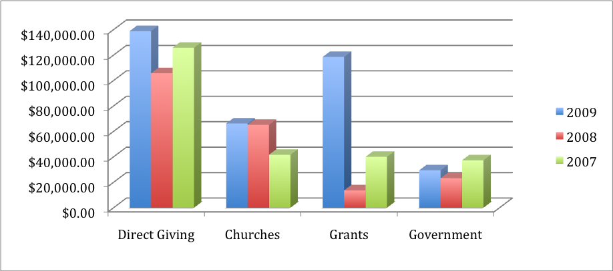

Historically, government funds have been specifically designated for use for operating the Cold Weather Shelter. For many years, the City of Fredericksburg was the sole contributor to the operation. Other Planning District 16 localities began to contribute in 2007. However, King George and Caroline have not continued their support as few members of their communities use the program. Fredericksburg, Spotsylvania, and Stafford continue to fund the program.

In 2010, Micah received several large state and federal grants for the first time. State Shelter Grant and Emergency Shelter grant funds were awarded to assist with maintenance and operations for the Cold Weather Shelter and Residential Recovery Program. The organization also received funds from the federal Housing and Urban Development Authority to boost its ability to steer chronically homeless individuals into permanent supportive housing.

Micah is committed to pursuing new funding sources; however, we are concerned about long-term reliance on grant funding. Mary Washington Hospital has remained a significant grants partner over the years, contributing first to the health advocacy activities at the Hospitality Center and transitioning to an important role in developing then Residential Recovery Program, which has a direct impact on both their bottom line and efforts to promote access to quality health care. We are hopeful the hospital foundation’s continued support will someday evolve into a business relationship that models that of the Moss Free Clinic.

We have already developed this kind of arrangement with the Rappahannock Area Community Services Board, who receives grant money through the federal Partners Assisting in Transitions from Homelessness (PATH) program. This money puts a caseworker on Micah’s payroll and funds an outreach worker, an RACSB employee who works from the Micah Center. This relationship comes with additional technical support for the Residential Recovery Program, the use of one of their buildings for the cold weather shelter and expedited assistance enrolling clients in services.

The United Way, Women Engaged in Service (WINGS), Sunshine Lady Foundation and Community Foundation have also made grants to the organization.

Much of our direct giving stems from regular outreach in community churches and organizations. We have also been fortunate to receive an array of positive publicity in The Free Lance-Star, the Chamber of Commerce newsletter, and other local publications.

4.2 Church Giving

Church contributions come largely from the nine governing churches, who by affiliation pledge $5,000 per year. Many churches contribute more than the required amount. Fredericksburg Baptist has financed the more than $90,000 hospitality renovation project, recruited substantial donations for other activities (i.e. staffing, cold weather renovations), supported a weekly community dinner, as well as coordinating groups that volunteer for Micah service activities. St. George’s has annually contributed more than the $5,000, in addition to hosting a community dinner, sponsoring volunteer groups, and convincing members to give large donations for special projects. In addition to their annual contribution, Fredericksburg United Methodist, Shiloh New Site, and The Presbyterian Church all host a meal at their churches and serve once per month. The Methodist and Presbyterian Church also support special collections in their churches, support a volunteer shopper, and actively recruit volunteers and teams for special projects. St. Mary of the Immaculate Conception serves three meals per month, sends a wealth of volunteers Micah’s way, and provides a volunteer shopper. Trinity Episcopal also supports a very active volunteer shopper, brings many people to participate in special projects, and for years hosted the hospitality center at its church. Shiloh Old Site has an active women’s group who work the Hospitality Center breakfast every Thursday morning, a volunteer who shops for Micah once every few weeks, and groups that work on special projects. Christ Lutheran supports the standard annual contribution, holds special collections of funds and in-kind gifts, provides food, volunteers and a facility for weekly community dinners

In 2010, Micah has secured some additional funding from churches by setting up a partnering church opportunity. Mt. Ararat Baptist, Tabernacle United Methodist, and Ebenezer United Methodist are currently on board as partnering churches. These groups commit to pay $1,000 per year and fulfill mission, financial, and information passing requirements. Most have given more than the minimum contribution, either in dollars, volunteer teams, or publicity. Additionally, there are several churches and their memberships in the greater community that give various amounts to Micah each year, but have yet to fully commit as partnering churches.

4.3 Expenses

As Micah has aggressively worked to end homelessness in the Fredericksburg area, the organization’s expenses have almost doubled every year of its existence. Many of these dollars have been channeled into a new program or new facility coming to fruition each year for the last three years. In 2008, we renovated and opened the Micah Hospitality Center in its current permanent location on Princess Anne Street. In 2009, we renovated and opened the cold weather shelter out of an RACSB building called the Old Little Falls School. And, in 2010, we secured state group home licensing and funding to open the Residential Recovery Program out of a 4-bed-room house in downtown Fredericksburg.

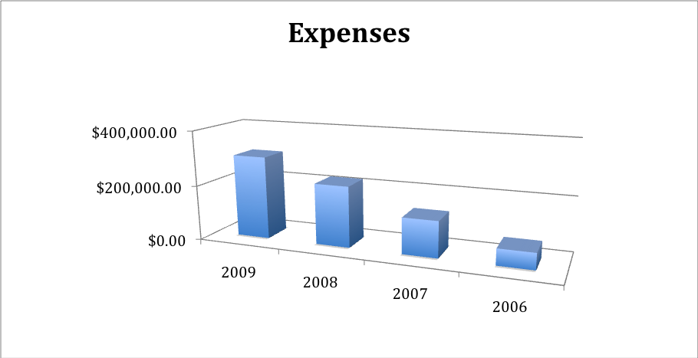

Programs, however, have expanded much more rapidly than paid staff. The organization has depended heavily on volunteers and maintains just one or two employees, with three or four seasonal staff for the cold weather shelter. This has kept our overall costs for salaries and benefits lower than the total spent on program operations, but that is expected to change. Efforts have been put forward in 2010 to implement a staffing plan that better balances the work-load, successfully addresses guest needs and effectively supports the growing team of volunteers on the front lines. Staff who have been added this year are directly related to program implementation. They include those who operate the Residential Recovery Program, a support services person that runs the Hospitality Center, and a Volunteer Coordinator, who also comes with a mixed social work and ministry background. Another notable part of our past expenses has been those dollars used to directly assist clients with hotel rooms, rent, IDs, prescriptions, transportation needs, food, sleeping bags, and tents.

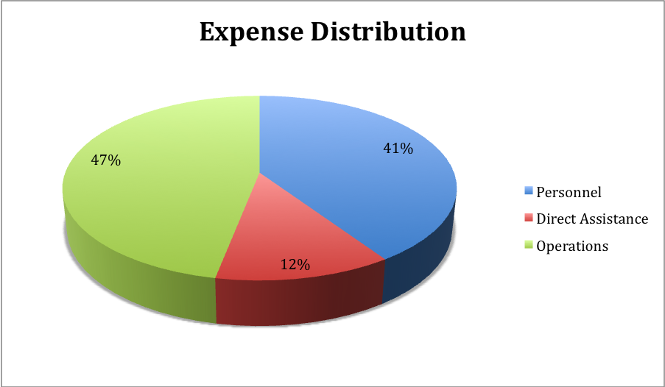

Micah has operated largely on a “faith” budget in its initial years. Expected expenses and funds are always presented each December to guide the following year. But rapid growth in the organization, including several unanticipated capital projects, have caused some differentiation in the actual expenses and income each year. While it is important that Micah maintain a flexible budgeting strategy—remaining open to opportunities that require rapid action—there is a need to project timelines for long-term projects and plan funding solutions so that we are ready when they arise.

5. Conclusion

Micah’s community of churches has come together out of belief that they could be more effective as a combined force than they could as particular congregations. While the organization’s current focus surrounds the issue of homelessness in our community, we remain open to a wide range of emerging needs. The ultimate goal is that all people, through the work of Micah, will encounter Christ on earth. For those reasons our mission remains broad and our eye is on the horizon in anticipation of new calls from God.

6. Micah Ecumenical Ministries Strategic Plan

In 2010-2011, Micah’s Board of Directors began the process of formulating a strategic plan to guide the organization for the next five years and will be reviewed to annually prior to budget preparation. As a part of that process, Micah’s Executive Director worked with a pro bono consultant with experience in non-profit strategic planning. The first stage of the process involved the hosting of a series of focus groups. From August to October 2010, Micah sponsored nine different focus groups. Discussions were held with the board, clergy, volunteers, community partners, staff, and clients. Each group analyzed the strengths and weaknesses of each Micah program. They discussed the mission statement and ways they experience the Micah community and they brainstormed directions for Micah’s future. At the same time, the Executive Director encouraged each Micah Board member to hold conversations with members of their congregations. Several accepted the challenge to comment on existing gaps, current successes, and future hopes.

After the completion of these focus groups and conversations, the Executive Director compiled the information into a preliminary document. The Board of Directors, in conjunction with Clergy Caucus, then outlined its priorities for Micah’s future and its plans to achieve those goals. The Board gave its final consent to the strategic plan on 09/13/2011.

Micah’s strategic planning process reaffirmed that the organization will need to expand in four key areas in order to meet the growing needs of our community. Housing, health care, education, and employment are all necessary components of ending homelessness. Those connected with Micah emphasize the simplicity and interconnectivity of services offered. It is therefore recommended that the organization grow with the following diagram in mind—the Micah Center is intended as the hub of operations with additional programs developing under the umbrella of one of the four focus areas. Additional efforts can be put toward community building, development, volunteer coordination, advocacy, and awareness, as a means of attracting resources, support, and infrastructure for the direct programming.
Micah Center
Housing
Employment
Health
Care
Education
Community Building
Development
Volunteer Coordination
Advocacy/ Awareness

6.1 Strategic Planning Objectives to be Implemented by Micah Staff

The Executive Servant-Leader has decided to facilitate a number of changes to current programs as a result of information gathered during the focus groups. For the most part, these changes can be instituted using current staff and will make immediate improvements in the functioning of the organization.

Making Services More Hospitable
Micah has a hospitality center that is not as hospitable as it was originally intended to be. While brainstorming ideas in the Fall of 2010, the following concerns were identified:
• Staff and volunteers never seem to have enough time for individual client needs. Everyone is always too busy to take the time to really understand an issue and troubleshoot it. Staff is equally frustrated that there is not a way to carve out uninterrupted time for critical needs.
• There is no process for outreaching needs, moving people out of homelessness and working at an individual’s pace. There is more focus on “the herd” and getting through operating hours.
• The current service method includes waiting lists, long lines, and rules that are impossible to enforce—such as loitering on the sidewalk and not arriving before the door opens.
At the beginning of 2011, staff replaced the existing operating hours, 9:30 to 11:30am, with a new schedule that spread services throughout the day. Breakfast is now offered from 8am to 9am and guests are assigned an hour time slot, where they can come between 10am and 2pm for case management and basic need services. This strategy has provided a better environment. Guests appreciate the flexible structure, the volunteers are less overwhelmed by the need and staff is able to spend time troubleshooting real needs. Yet, there remains room for improvement across Micah programs.

HOSPITALITY OBJECTIVES
To perfect service provision among all programs, so that the Micah experience is as close to home as possible for those without.
• Outline a system that will better manage the ebb and flow of crowds throughout the day.
• Identify ways to increase individual attention to guests. (i.e. provide volunteers in a host/hostess type way, structure processes so that guests who need to be heard can find a person to listen)
• Revamp the intake and service process in a way that maximizes the assistance to the community, yet limits the Micah “caseload” to the most vulnerable individuals.
• Revise the intake chain of command so that volunteers are in positions of helping not turning people away.
• Increase community building activities to put Micah in a position of being more like a “family care network” than a service system.
• Implement a calendar that outlines upcoming activities—from giving back to therapeutic and community building opportunities—one month in advance.
• Re-direct volunteer training emphasis from managing people to assisting individuals one at a time by identifying needs, developing a plan, and working people out of homelessness at their own pace.
• Develop ways that staff can share the burden of a longer operating day and the same work load.
• Create a system, where every person enrolled in the Micah program has a plan to address both immediate needs and long-term steps out of homelessness.
• Introduce support groups, where guests have the opportunity to build community around anti-trauma, substance use and pre-contemplative matters.
• Improve communication between programs and between staff at different locations. (i.e. Intake, mail and message sharing)
• Look into productive ways to work with guests on acceptable behavior.
• Find ways to recognize guest monthly birthdays

Reassessing Staff Needs and Organizational Responsibilities
Micah intends to proceed on a path that minimizes paid staff and maximizes the gifts and talents of community volunteers. Volunteers, including guests who work in the Giving Back program, are one of the most crucial manpower resources available to Micah. There are, however, program areas where volunteers are being over-utilized or not being used to their greatest potential. At the same time, Micah maintains a diverse staff that relies on each other to fill important service roles. But the nature of various paid positions, mixed with heavy volunteer support, does not always offer the most consistent continuum of care for all who come to Micah for help. The two areas must be balanced well enough that staff can offer efficient operations and volunteers can engage in meaningful experiences. Micah will address this challenge in the following ways:

MANPOWER OBJECTIVES
To further expand the community of partners, both paid and volunteer, who are working on the Micah cause.
- Volunteers
• Recruit more volunteers to be a part of key positions
• Develop a system that limits vacancy in volunteer roles when someone calls out sick, goes on vacation or leaves.
• Identify a mechanism where guest volunteers, who are on the street or living in supportive housing, can contribute to Micah, while not being too much or too little help for the situation.
• Layout a volunteer recruitment, placement, training, and programming strategy that addresses existing areas where volunteers are under-utilized and aspires to tackle new need growing programs.
• Create a new level of volunteers—mentors—who participate in the supportive housing level of Micah programming. These volunteers will work with staff in doing regular apartment inspections, teaching skills of daily living and supporting rules and program plans.
• Develop a consistent way for volunteers to transport guests to appointments.
• Stabilize the Journey program structure and training opportunities
• Expand the Journey program to the Residential Recovery Program, so that at least one guide is available specifically for respite needs each day.

- Paid Staff
• Make use of temporary employment programs, such as Agency on Aging and Americorps, to address the most urgent staff needs.
• Identify sustainable funding sources to support long-term staffing needs.
• Hire new staff to coordinate Micah’s housing efforts--the cold weather shelter, rapid re-housing and supportive housing. This person would supervise volunteers or church mentors who manage specific areas of support. He/she would build relationships with landlords, develop the program, recruit funding resources, and be the case manager for shelter services.
• Hire new staff person to coordinate Micah’s employment efforts, both the Giving Back program and a long-range transition into mainstream work. Volunteers could be used to deliver some aspects of this service, including resume building and job coaching, but the staff person would coordinate all related activities.
• Add a weekday staff person at respite to free up the case management staff to be less responsible for supervision and spend more time managing individual client success plans.
• Work toward a respite staff person that can focus specifically on groups, counseling, more intensive mental health needs and management of appointments, etc.
• Better define the role and supervision of Agency on Aging staff, who work in positions at Micah, but are paid through RAA.
• Explore partnerships with other agencies, so that positions crucial to Micah’s population can be protected or expanded.

TRAINING OBJECTIVES
To form a more consistent and equipped team of staff and volunteers
• Increase opportunities for volunteers to know what is available to guests in-house and throughout the community.
• Cross-train staff and volunteers who work in different areas to understand processes that others are responsible for, so that they can be supportive of the overall Micah team.
• Define and implement ways to empower volunteers in decision making and managing processes that have been laid out.
• Sharpen volunteer skills in hospitality, case management, service delivery, resource understanding, knowledge of Micah services through training.
• Provide more specialized training in specialized volunteer areas, such as respite journey and supportive housing.
• Improve consistency in the rules and program expectations (i.e. proper channels for referrals to services, rules, etc.)
• Increase staff development opportunities, from training to fun outings that build relations.
• Conduct a compensation study and ensure Micah staff is paid comparable to those in the area, who work in similar positions.

GOVERNANCE OBJECTIVES
To better define the different responsibilities of the Clergy, Board and the Executive Servant-Leader.
• Facilitate discussions among the Clergy Caucus and Board as to what responsibilities belong to each and which areas are redundant among both groups.
• Develop role descriptions for members of both the Clergy Caucus and the Board.
• Work with the Clergy Caucus to ensure that it focuses more on its responsibility for the organization’s vision and takes a more active role in its ministerial functions.
• Work with the Board of Directors to ensure that it takes responsibility for planning, fundraising, advocating, and carrying out Micah’s mission.
• Create accountability mechanisms (i.e. board contract) that hold the board and clergy accountable for their respective responsibilities
• Focus the agendas of Clergy Caucus and Board of Directors meetings on the particular responsibilities of each group.

Offering Coordination to Community Meals
Community meals are one of the most self-sustaining, eye-opening, church-owned experiences offered by Micah. But there are several ways Micah can work to improve the overall experience:

COMMUNITY MEAL OBJECTIVES
To improve accessibility, communication and consistency among community meal sites
• Coordinate uniform training opportunities for volunteers involved in the meals.
• Ensure that at least one person trained in behavior management attends each meal and provides other volunteers with the necessary information about community resources and proper responses to needs that arise among clients.
• Develop a food service training for the community meal groups.
• Define consistent ways for guests to participate in preparing and serving the meals.
• Develop an online meal-sharing tool, so that churches can compare menus and avoid duplication.
• Create a mechanism that share each night’s menu with guests who plan to eat at the various churches.
• Provide better communication with the meal groups as to when the cold weather shelter is open or not.
• Host regular meetings and e-mail exchanges between dinner groups and Micah.
• Develop a communication tool to improve passing of information among the dinner groups.
• Expand the audience receiving the community meal calendar by identifying more flyer distribution sites.
• Coordinate with each meal site to provide signage for the various meals.
• Create a set of common guidelines for community meal volunteers. (i.e. dos and don’ts, how to handle situations, youth volunteers, guest participation, what to do with extra food, taking pictures, community services available, ways to be hospitable/break the ice, etc…)
• Work with meal sites to create a site-specific information sheet—location of phone, electric box, how to use equipment.
• Create a process for meal groups to instantly communicate problems or needs identified at the dinners back to Micah staff (referral form, on call staff person).
• Set-up transportation to the Wednesday night dinner at Christ Lutheran or find an alternate location closer to the center of town.
• Work with meal sites to add community-building elements, such as music and games, to the dinners.
• Encourage participation of church pastors in the community meal operations.

Keeping Tabs on Advocacy Areas

The Executive Servant-Leader and staff must be constantly aware of ongoing issues that involve advocacy with community partners and other local entities.
• More people are living in camps and in cars in public parking lots and it is difficult to keep belongings safe and undamaged
• Homelessness does not get the necessary attention because most are not voting constituents.
• There should be a more confidential way to address police when they are looking for someone with a warrant or subpoena. There is a perception that Micah is too helpful to the police. And there is a tendency by the police to search the homeless population first for offenders.
• The general stereotype of homelessness keeps some from getting jobs or moving on in society. Certain laws actually prohibit some from getting jobs and finding housing.
• Relations with the hospital and the jail could be improved
ADVOCACY OBJECTIVES
• Continue working with the Fredericksburg Police on issues relating to campsites and arrests for nuisance crimes
• Consider ways (private voice mail system, mail receptacle and method of police communication) to protect the anonymity of clients.
• Explore additional ways of educating the hospital and the jail staff, as well as other community partners
• Encourage the counties—Spotsylvania, Stafford, Caroline and King George—to take more responsibility for the homeless.
• Explore mechanisms to garner political support on homeless in our area
• Publish best practices to educate other communities and local agencies on successful strategies.
• Increase the community distribution of factual information about homelessness; dispel myths with positive marketing of the program and its people.
• Set up more opportunities for community partners and representatives of local governments to learn about Micah and its people. Arrange ways to take the conversation into their offices through outreach, meetings, etc….
• Organize more opportunities to interact and come to know the homeless population and what Micah does to address their needs (come and see, poverty simulation, Micah Sunday, client talks)
• Develop planning sessions where key players in advocacy areas have an opportunity to work through trouble spots together.
• Set up a voter registration drive
• Start an input group, at least quarterly, where clients have opportunity to bring up problems they are facing and discuss ways they, as a population, can work toward solutions.
• Place someone in the role of answering the phone and providing instant answers during business hours.

The Executive Director and Staff have already begun to implement many of these changes and intend to have many of them in motion by the end of calendar year 2011.

6.2 Strategic Planning Objectives to be undertaken by the Board of Directors
As a result of the strategic planning process, Micah’s Board of Directors has designated the following as its priorities for the future:

What are the next major program areas for Micah?
The elements of housing, employment, health care and education are seen as crucial components connected to the central hospitality center services. There is a sense that Micah has a more substantial role in the realm of housing and employment. The two areas are seen as intricately connected because housing cannot be obtained without the income from employment and employment cannot be maintained without housing stability.

Housing and Support Services
There needs to be a diverse offering of housing options, ranging from affordable alternatives for those who are simply low-income to more involved situations, such as supportive housing and group homes. Placing homeless people in housing as quickly as possible and providing support services until they can prove sustainability is nationally recognized strategy for ending homelessness. Not only does it provide better continuity of care and advance the quality of life for those in need, it reduces costs on hospitals, jails and public safety—which expend extraordinary amounts of time and dollars managing homeless people on the street. Given the nature of Micah’s target population, the connection between physical housing units and supports—from case management to financial backing—is of the utmost importance. Micah plans to develop its housing services in the following ways:

- Supportive Housing Programming
  - While Micah has permanently housed almost 70 chronic homeless individuals, since 2008, staff estimates there are approximately 158 different homeless at any given time that could be housed under the right circumstances. Efforts to re-house remaining homeless and sustain those who have already been housed are challenged in several ways:
• The area housing stock remains limited and incomes for this population are difficult to obtain and maintain.
• Units that do become available to clients are often too expensive and/or poorly maintained.
• It is difficult to find suitable land, close to services and transportation, in an area that housing for the homeless can be accepted by the neighbors.
• Supportive service responsibilities are absorbed by existing positions, which have primary focus on other areas. No one person works solely to re-housing people and preventing them from returning to homelessness.
• Myths about homelessness discourage community partners. Specifically, there is a concern that if our community succeeds in its care for the homeless, more people in need will come.
• Client mental health, substance abuse and general habits jeopardize their ability to stay in units in which they are placed.
• The previously homeless are not sure where they fit once they move into housing. They no longer need Micah in the way they did while on the street, but their risk of becoming homeless again remains high. They succeed better when staying connected to services, but not so closely that they become dependant or the struggles of existing homeless drag them down.

SUPPORTIVE HOUSING PROGRAM OBJECTIVES
To develop a multi-pronged effort that houses and supports the primary street population.
- Add a case management component that both oversees rapid re-housing and support services for those who have moved indoors.
- Hire residential, case management and administrative staff to implement the program.
- Define a mechanism where volunteers can mentor and serve as a role model in the supportive services aspect of the program.
- Roll out a supportive services program that involves unique in-house features, such as discussion groups and basic need provision, as well as partnerships with agencies that already provide support services.
- Develop a network of landlords willing to rent well-maintained, private units to Micah clients.
- Look into land and logistics for building or redeveloping a community of multi-use housing--single room occupancy units, single-family homes/townhomes and group homes/intensive supportive living situations.
- Purse partners (developers, other non-profits, etc.) that can lead housing development activities.
- Identify funding sources—grants, capital campaign, tax credits, investors, etc.—that construct and maintain the necessary buildings and operations for a supportive housing program.
- Encourage a community-wide solution to the housing problem by inviting key community players—elected officials from all jurisdictions, housing assistance agencies, civic groups, the United Way etc.—to the table.
- Organize opportunities to take partners to visit housing programs in nearby communities, so that can get a better understanding of how they can support efforts locally.
- Develop a level of programming that offers community and support to those who “graduate” from Micah’s homeless programs. Individuals need to transition from being a homeless client at Micah to a productive, housed member of society. Yet they need to remain connected enough with Micah, that staff can step in and troubleshoot when circumstances threaten to send them back to the same predicament.
- Promote success stories of those who have moved from the street into housing successfully.

- Emergency Shelter
Micah operates a Cold Weather Shelter that opens Nov. 1 and closes in early to mid-March, based on the temperature being below 32 degrees. During the 2010-2011 season, the shelter opened 70 out of 120 possible nights. Emergency shelter needs of the chronic homeless are therefore challenged by the following circumstances.
• The area’s only year-round shelter is often full and difficult to get into and Micah has a shelter space that is closed most of the year and sporadically throughout the winter. There is not a guaranteed place for someone who it homeless tonight to be able to go so that she/he does not have to sleep outside.
• The existing cold weather shelter space is often crowded and far from town, which is difficult for people who miss the bus or have trouble with crowds and small spaces.
• The shelter is simply a place to sleep with no case management component.
• The more nights the shelter is open, the more people stay there. This increases the cost, staffing requirements, behavior issues and need for programmatic elements
• The special use permit would need to be expanded if the shelter opened beyond November-March.

EMERGENCY SHELTER OBJECTIVES
Micah’s role in sheltering the homeless is strictly emergency. Beyond providing relief from the cold, our long-term plan is to direct remaining resources toward permanent housing. In the meantime, our emergency shelter efforts will be improved in the following ways:
- Work toward expanding the shelter to open Nov. 1 through March 30.
- Develop volunteer structure that minimizes need for staff expansion
- Assign case management staff to outreach those staying at the shelter and connect them to services that can expedite their transition off the street.
- Identify a sustainable funding source for expanding the shelter to be open more nights during the winter or longer.

- Prevention through Financial Assistance
Micah currently provides minimal financial assistance to those we have moved into permanent housing and are receiving support services. This includes both direct giving and assistance contacting community resources that will provide funding. Challenges include:
• The community, churches, and general people in need want to use Micah as a prevention and supportive services source. Micah, however, has not yet found its identity in that area.
• Prevention needs range from rent and utility support to assisting with basic needs so that those on the edge can sustain themselves.
• There is a sense that Micah best understands how to help an individual in need most immediately, but that help is not accessible at the time that it is needed. But Micah is ill-equipped in staff, process, and funding to serve the desired clearinghouse function.
• Clearinghouse efforts in the past have had negative results (i.e. money has been exhausted by early in the month, agencies giving the money became frustrated that people they wanted to help couldn’t get help that way, etc.)
FINANCIAL ASSISTANCE OBJECTIVES
While Micah does not see itself as a community-wide financial assistance provider, it does plan to participate in the larger issue as a catalyst for community dialogue.
- Determine whether Micah is interested in serving a clearinghouse function for homeless prevention needs.

B. Employment
Micah has yet to fully tackle the issue of employment. The need for this service begins with productive volunteerism opportunities for the disabled or lower-functioning guests, who present significant barriers to working in the mainstream market. It extends to a more comprehensive level that offers skill development and even micro-economies that offer intensive job coaching. There needs to be more focus on helping clients get and maintain jobs from start to finish. These needs will best be met by maximizing on the volunteer labor that Micah has at its disposal and tapping into the resources already offered by community partners. This approach will allow Micah to build on two aspects of its loosely defined existing programming:

1. Technical Assistance
a. Currently, staff and journey guides support employment searches by assisting with applications and transporting clients to possible employers, as needed. These efforts, however are challenged in the following ways:
• There is a limited job market at this current time, particularly in fields that Micah clients specialize (construction, production, trades)
• Micah clients, who have a high rate of substance abuse, mental illness and criminal backgrounds and fines, don’t have an edge against those whose background is spotless.
• There is little to no outreach or coordinated process for those who may need an extra nudge.
• The program lacks functional computers/equipment for clients to use for applications and employment correspondence.
• Community services that offer employment services are not case management-based; they require clients to take initiative and manage themselves.
• Micah’s typical homeless client has low initiative, lots of excuses and poor follow-up in accessing other community job assistance resources. Most clients are skeptical of systems and their own abilities.
• Many Micah guests are approaching the job market without proper documentation (picture ID, social security card. Birth certificate)
• Guests lack reliable transportation. They usually do not have driver’s licenses or cars and the FRED bus is unreliable and costly.
• Many guests do not have computer skills or an email address, yet many applications are only accessed online.
• Guests require support through the job application process, but also while settling into a daily work routine.

TECHNICAL ASSISTANCE OBJECTIVES
To improve the application, resume and job search assistance provided by volunteers, staff, and community resources who come to Micah.
- Set up a job board that announces known job openings.
- Create an in-house dress for success program, including workshops and opportunities to obtain items that guests could wear to an interview/work. This could include various work-ready outfits, packaged by size, that guests could check out and return so that storage/preservation of nice clothes would not be a problem.
- Develop a training mechanism for volunteers who will shepherd a Micah guest through the employment process. This begins with understanding an individual’s needs, taking them to an employment assistance service, guiding them through applications/interviews and mentoring them on the job, as needed.
- Create in-house mechanisms that focus on the basics of resume writing, interviewing and job readiness
- Initiate partnership opportunities with Rappahannock Adult Education for those who would benefit from obtaining a GED or gaining basic literacy.
- Formalize Micah’s job assistance program to include enrollment, assessment and triage to the right path of workforce re-entry.
- Maximize partnerships with Virginia Employment Commission, Goodwill Job Help Center and Department of Rehabilitative Services, which is already providing full-fledged technical assistance services. Appointments can be made with staff and volunteer mentors can attend with the client to serve as the “notepad,” keeping track of what’s needed to move forward.
- Install a staff person to coordinate the many people working to connect guests to various services and move them through the employment process.
- Formalize efforts to tap into the “ticket to work program” so that those receiving disability might increase their incomes or transition completely into the mainstream work market.

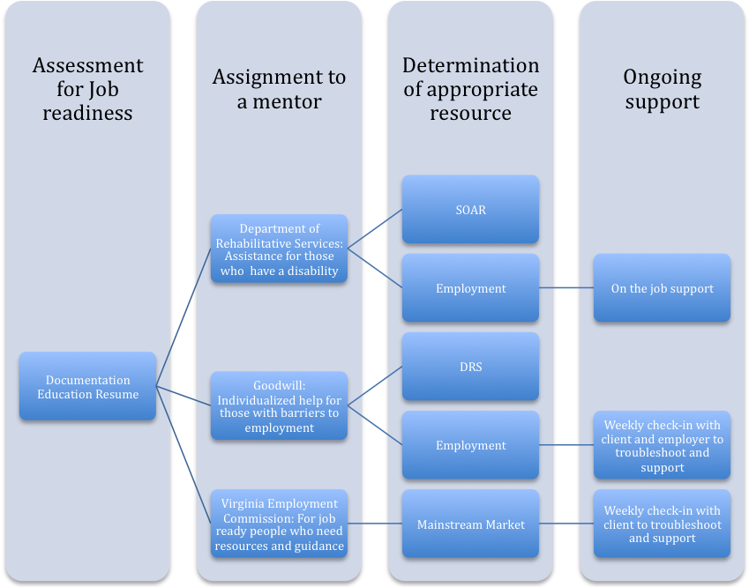

2. On-The-Job Training
a. Currently, Micah provides an array of Volunteer opportunities, such as cleaning facilities, community landscaping, litter pick-up, etc., which are rewarded with various incentives (i.e. bus tickets, laundry privileges). The program gives self-worth to guests and gives staff an idea of various client skills and habits. The program is challenged in the following ways:
• The Giving Back program is seen as a “dead ended opportunity that is time and skill limited.”
• Guest’s desire to participate outweighs the number of opportunities and hours of service available.
• It is poorly publicized, given the community enthusiasm about the program concept.
• Incentives offered are not always significant enough or well-stocked. (i.e. batteries, meal cards, movie passes, entry to community events, cell phone minutes, radios, lanterns, stoves, alarms, fun stuff, new clothes, gift cards).

ON-THE-JOB TRAINING OBJECTIVES
To develop Micah’s giving back program as a multi-tiered employment project that both meets productive volunteerism needs and serves as a stepping stone for those needing to work through a program, learn skills, grow personally and transition back into the mainstream workforce.
- Expand giving back opportunities:
  - Include task-oriented projects that offer transferrable skills that can move into the mainstream market. off
  - Offer work-like schedules, with longer hours, a more consistent group of workers and more valuable incentives.
  - Examples: community dinners, serving other non-profits, supporting the tourism office by dressing as civil war re-enactors, assisting businesses that may eventually hire people, using individual skills for specific purposes, serving in volunteer roles at Micah that are typically reserved for non-homeless)
- Research and develop the tools for providing supportive employment
- Organize opportunities to take key community players on trips to other nearby programs to learn how on-the job employment programming could be developed locally.
- Find ways to balance the potential for giving back volunteers to work on a schedule with their need to have food, clothing and shelter. (i.e. those who work in the program get chosen basic needs met in exchange for their time.)
- Develop a marketable program that offers a vetting system, skill/barrier assessment, client program agreement, supervision, mentors and employment-like elements.
- Marketing skills and abilities to the community for daily, weekly or permanent jobs.
- Research tax and liability implications of contract and micro-economy opportunities.
- Hire staff to implement the program
- Generate seed money for tools, equipment, incidentals
- Create partnerships—parks and recreation, habitat, city, FRED bus, university—that could offer work-like giving back experiences and turn into paying work.
- Build a network of mainstream market employers (i.e. custodial, gardening, maintenance, etc.) who will hire from Micah’s pool of clients who have reached a point of employability.
- Recruit partners that offer “contract” projects
  - Maximize on the need for employers to fill paid positions they have had to cut (janitorial, landscaping, etc.)
  - Tap church groups, small businesses, private landlords, local governments
- Create MOU between “contract” sites and Micah. MOUs will define expectations and whether a monetary or in-kind donation will be exchanged.
- Train “contract” sites on program structure, challenges of the population and opportunities to hire those volunteering in the project, if their work is deemed acceptable.
- Market the program as an economic stimulant. Rather than taking jobs away from already employed people, the program assists the needs of employers who can’t afford employees for certain jobs and it provides resume-building opportunities to people in need. In turn, these opportunities will not only better prepare people for the workforce, they will improve the potential for businesses to reach a higher potential.
- Choose one or more micro-economy opportunities—thrift store, moving company, restaurant, landscaping, snow removal, apartment turning.

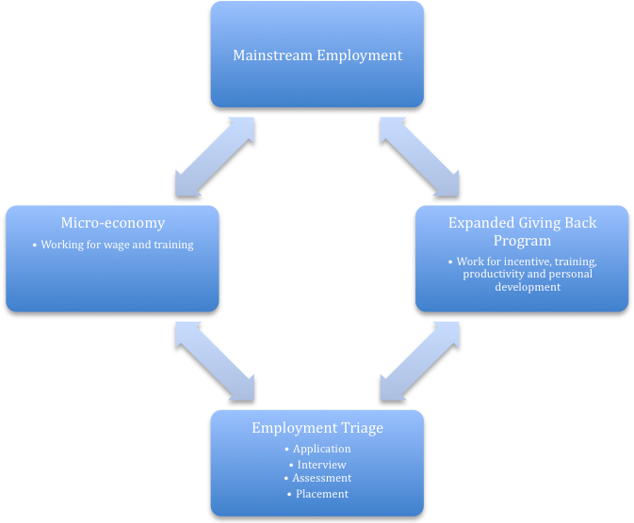

How can we better market Micah and help the community understand its population?
There is a mixed community perception, even among the clients, about Micah clientele and the work that is taking place. Some people believe there are those who will always be homeless and are not worthy of the services provided by Micah. Others wonder what the community would be like without Micah. Overall, it is recognized that Micah is doing some remarkable work, but many in the community and the churches still do not know about the organization or understand the depths of the lives it is changing.

- Community Perception and Marketing
Challenges include:
• While some see the homeless as a nuisance that ties up public resources, such as the police and the hospital, others believe Micah’s work actually reduces these burdens.
• Some, including clients, believe that those drinking alcohol, using Micah as a hang out, and not trying to help themselves should not be allowed to use Micah. These are typically the same people blamed for activity in camps that results in shutdowns. This is contrary to Micah’s mission of serving the most vulnerable and least assisted.
• While some have general concern about the location of the hospitality center in the middle of town, others feel it is a perfect location because it keeps homelessness visible and challenges the community to step up.
• While some still believe homelessness is better hidden than made known to the general public, there is an understanding among those who have taken time to get to know the population that a relational, family-like level of service from the entire community is required for Micah clients to succeed.
• There is a perception that Micah does such a good job that it is causing Fredericksburg to be a magnet for the homeless population throughout the country. This idea comes regardless of other factors that draw people to Fredericksburg, including its proximity to I-95, and many guests’ legal obligation to stay due to probation restrictions.
• There needs to be more regular and wide-spread communication about activities, resources and operations (community meals, website, giving back, volunteer opportunities, Facebook, SA meeting lists, action team packets, church visits, general needs).
• More information should be distributed regarding the cost of solving homelessness versus merely managing it. This can include more conversation about Micah successes and use of the Giving Back program

COMMUNITY PERCEPTION OBJECTIVES
To grow community understanding of those who live on the street and the community’s role in addressing the issue.
  - Both numbers and stories can be used to communicate Micah’s philosophy that ending homelessness is far better and cheaper than managing it.
  - Offer community building activities that assist clients in better understanding each other’s problems.
  - Get the hospital, police departments, the jail and the court system to help generate a cost analysis
  - Find forums to publicize and speak about the cost-benefit analysis (United Way, media, Chamber of Commerce, local governments, etc…
  - Work with guests to get their stories on paper for use in newsletters, presentations and displays
  - Develop an aggressive marketing campaign that involves print media, the internet, video, radio/broadcast, facebook, twitter, speaking engagements, and other opportunities to get to know the population.
  - Create more opportunities for Micah guests to interact with the greater community in non-service settings (i.e. cookouts, athletics and other fellowship opportunities)
  - Identify intolerant parties and invite them into a larger conversation about homelessness in the community (i.e. luncheon with downtown businesses, invite stakeholders to community dinners, hold an open house with those who don’t understand homeless etc.)
  - Find ways for those with limited or no understanding of poverty and homelessness to experience it (i.e. poverty simulation)
  - Develop a better understanding of legislative changes on the local, state and national level and mobilize efforts to effect policy.
  - Find ways to bring the county governments into conversation with the city about the homeless issue.
  - Maximizing on the giving back program as a way to demonstrate a different side of the homeless population (service projects, deliveries, etc. that pull people into relationship with clients)

B. Church Connections
Micah’s connection with the churches is varied.
• While some regularly talk about Micah in multiple fashions, others do not. The Board assumes that the clergy are communicating all that needs to be communicated about Micah to their churches.
• People are largely failing to see Micah as a part of their congregations. Their greatest connections to Micah come when Micah comes to the churches, through community dinners, speakers, through the hospitality center, and when the clergy or board have taken time to get to know the clients in a way that they can share their stories.
• In the interest of preserving Micah as a faith-based organization, there is question about where Micah’s faith element comes into play. Should there be bible study or a mechanism for spiritual nourishment? The churches and clergy could be more present to Micah as a means to make guests and volunteers aware that Micah remains faith based.
• There remains some disconnect about the Clergy’s role. They want to be more active in visioning, brainstorming and bigger picture issues and less involved in operations, but there is interest in finding ways to connect with the work Micah is doing on the ground level by sharing their gifts of spiritual leadership, prayer and even bible study.
• Existing and prospective Micah churches each have people of influence and generosity in their pews, but they are not always receiving information that would cause them to act.

CHURCH CONNECTIONS OBJECTIVES
To find more ways to bring Micah into the churches; and get the churches and clergy to interact more with Micah and its population.
- Secure opportunities for Micah staff and guests to be in at least one church every Sunday.
- Identify opportunities for weekly church speaking opportunities
- Implement a Micah staff presence at the community meals on a rotating basis.
- Identify ways that the Clergy would be willing to be present in Micah services and interact with guests.
- Find a way to offer worship, bible study and spiritual guidance to guests who desire it.
- Look for ways to offer new and ongoing worship opportunities within individual churches and as an ecumenical group
- Launch a targeted effort to recruit additional partnering churches, with concentrated effort on smaller churches.
- Improve distribution of information (propaganda, items for bulletins, stories for pastors, regular report, thank you’s to churches/groups that explain how a particular gift is impacting someone) that will keep the churches interested and informed.
- Develop a “discipleship class” led by Micah staff that instructs churches on ministry and serving the poor.
- Find ways to engage adult and child education in learning experientially about ministry and the poor

Impact of the Mission Statement
The current mission statement does not move people to talk about Micah. It evoked mostly silence and semi-dry responses, absent of emotion. Meanwhile, the actual work of Micah induced some strong passions.

SUGGESTED SOLUTIONS
Re-writing the mission as less of a values statement and more of a declaration about the passionate work Micah does. Those involved in the strategic planning process used some of the following language to describe their perception of the Micah mission:
• “It is stepping up to the society obligation that they need to distribute resources fairly.”
• “Challenges,” “support,” “changes attitudes,” “place where people feel welcome and accepted for who they are,” “moral compass,” “Godly treatment plan,” “exemplifies basic Christian behavior,” “healing the world in all faiths,”
• “It is a CHRISTIAN response, which is different from other community responses of helping others: God speaks through us. “
• “Brings unlikely partners on the homeless issue together,” “Both addresses community concerns and defend the rights of the population,” “calls together an unbelievable level of support.”
• “Neighbors…it implies they are part of the community,” “Sense of family,” “Symbolizes love thy neighbor, help thy neighbor,”
• “Sometimes the only hope or last hope we have,” “ It is not just coming in and fixing their lives, there is ownership and responsibility,” “place where those who have help those who don’t
• “Micah is a place, a philosophy and an opportunity. It is a place that helps and inspires people to help. It is an opportunity for the haves and the have nots to share pieces of their lives. And its philosophy of doing justice, loving kindness and walking humbly with God challenges all people to accept the concepts of Christ-like behavior. It is a family of people, volunteers, guest and staff, that depend on each other in many facets, based on what everyone is willing to give.”
• “The mission is misleading: The way it reads it indicates help for all. It leads people to believe it is shelter.”
NECESSARY STEPS
- Form a committee and set a deadline
- Research mission statement examples
- Put together a revised statement to present to the board
In June 2011, as a result of focus group feedback, the Micah Board adopted a new mission, vision and core values statement. Staff and board members will periodically assess the impact of these statements to ensure they remain relevant and effective in our work.

Developing a Fundraising Strategy
There is no well-defined strategy for funding essential parts of the organization (i.e. expanded shelter, giving back incentives, taxi transport, direct assistance, let alone new initiatives). Fundraising efforts are challenged by the economy and public perception of the organization’s target population. However, Micah has a good reputation and could maximize on people’s willingness to give by making sure more people have an opportunity to understand the mission. This will be accomplished by a thorough development plan, events, grants and the establishment of business relationships.

DEVELOPMENT PLAN OBJECTIVES
To establish clear deadlines and strategies for obtaining and maintaining a donor base.
  - Donation receipt/Thank you notes sent within 5 to 7 days of the donation regardless of amount or size.
  - Direct mail letter sent quarterly to donor list with envelopes for returning donations.
  - Newsletter e-mailed monthly
  - Random thank you notes sent throughout the year to special givers
  - Letters sent after special collections or special gifts (i.e. tent and sleeping bag giving, etc.)
  - Equipping volunteers to speak on Micah’s behalf at mission fairs, group meetings, etc.

FUNDRAISING EVENT OBJECTIVES
To present opportunities for existing supporters of Micah to give in different ways and introduce new donors to the work Micah is doing.
- Establish a signature event (dinner, gathering, etc.)
- Develop a sustaining fundraiser (bingo/trivia)
- Put out a range of small events that occur several times a year and are repeated from year to year.

GRANT WRITING OBJECTIVES
To diversify grant opportunities for specific and general programming
- Explore local foundation opportunities
- Research state and national grant opportunities

BUSINESS RELATIONSHIP OBJECTIVES
To develop financial partnerships with individuals and organizations whose investment would assist their specific needs, while growing Micah programming.
- Identify large scale corporate sponsors willing to support single activities or ongoing efforts
- Pursue one time and ongoing bank relationships (i.e. NSWC, PNC, BB&T)
- Identify existing fundraising groups that would plan an event that raised funds for Micah or allow Micah to piggyback on their existing activities (i.e. great train race, scouts, VFW, etc.)
- Partner with school groups, up to and including events on the College campus
- Pursue relationships with organizations that have a special interest in specific aspects of Micah’s work (i.e. Hospitals/Hospice/Home Health=Respite, Fire/Rescue=Cold Weather Shelter)

6.3 Other Long Term Goals

Establishing round-the clock, year round programming
Micah is identified by a wide variety of people as a highly successful program strategy. The community enjoys the agency’s many features so much that it aspires to access it 24 hours a day, seven days a week in all temperatures and weather conditions.
• The limited operating period in our 4,000 square-foot building is not enough time for the 80 to 90 people to access the showers, clothing, breakfast and case management that they need.
• There is a sense among the street population of needing to compete with the more marginal, couch-dwelling and motel homeless.
• There is a feeling among the community that Micah is not available when it is sometimes most needed (i.e. extremely hot or cold days, nights, weekends, when it is cold outside, but not 32 degrees, and when they have outworn their welcome on street corners and other places such as the library)
• There is still a segment of the population that, seemingly by choice, is not using what Micah has to offer. “They are sleeping outside when we have a shelter for them; they are starving when we have food; they are being discharged from the hospital to the street when we have a place for them to go.”

Considering Micah’s role as charity medical provider
For those outside of respite care there is still a greater gap in health care needs among the homeless. For those in respite care there remains an ongoing battle for expeditious service.
• Those living on the street have difficulty remembering to take their medications, and keeping them from getting stolen or damaged.
• There remains ongoing difficulty in accessing primary medical and mental health care in an expeditious fashion. Enrolling in Moss Clinic and RACSB can take a week or more. Making nighttime appointments is challenging when the clients finish up after FRED shuts down. Sometimes the model provided by the Moss and RACSB does not cater to the needs of those living in places not meant for human habitation.
• Greater outreach is needed to service providers who may be able to send people to Respite care. Work could be done to smooth the referral process. Respite may eventually require more beds.

6.4 Long Term Funding Needs

• Resources for expanding the shelter
• Full-time positions: Housing Navigator, Employment Navigator, Education Navigator
• Part-time positions: weekday residential aide
• Leasing dollars and or capital for permanent supportive housing
• Grow direct assistance budget for prevention and giving back purposes
• Develop funds for volunteer programming
• Start-up costs for employment programming

